**Homework 4**

**Linear** **Mixed Model and Quantile Regression**

**Name:** Krishna Prasad Palvai

**Student ID:** 922672795

**Linear Mixed Model**

Imported nghs csv file into R. Cleaned the data set by selecting required variables and removing observations with missing values.

Response variable in this linear mixed model is DBP. Intercept is varied by ID. Predictors are age, BMI and race.

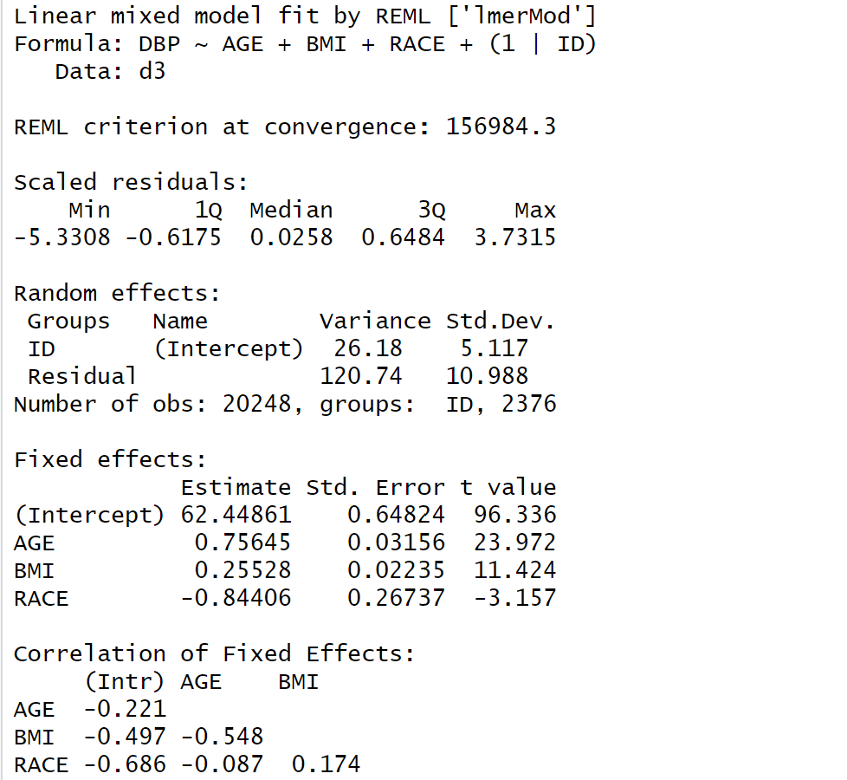

From summary of mixed model, it shows both random effects and fixed effects. Intercept is random, tend to vary from ID to ID. Coefficients of age, BMI and race are fixed. If age increases by 1 then DBP increase by 0.76 units. If race changes from 1 to 2, on average DBP decreases by 0.84 units.

**Quantile Regression**

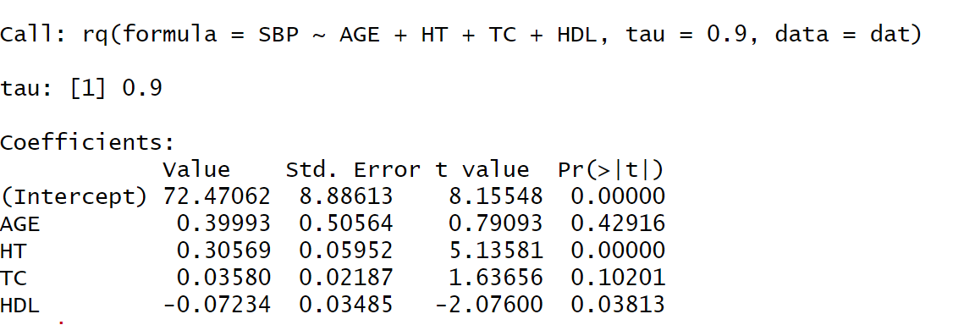

90th percentile of SBP is predicted using age, HT, TC and HDL. If HDL increases by 1 then 90th percentile of SBP decrease by 0.07 units.

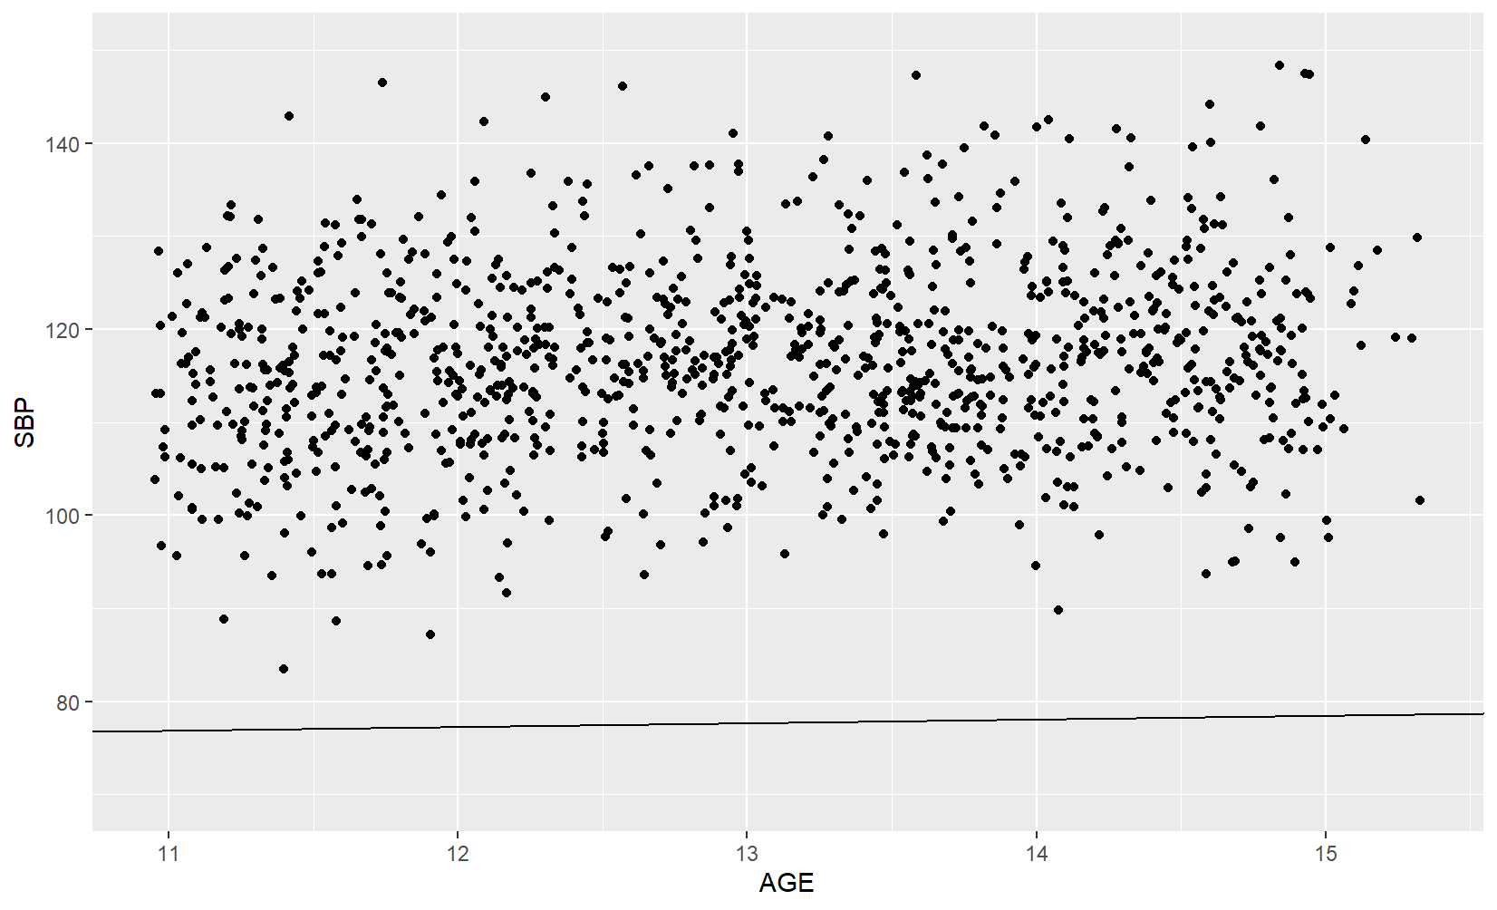

Plot of fitted 90th percentile regression line versus AGE variable is shown.